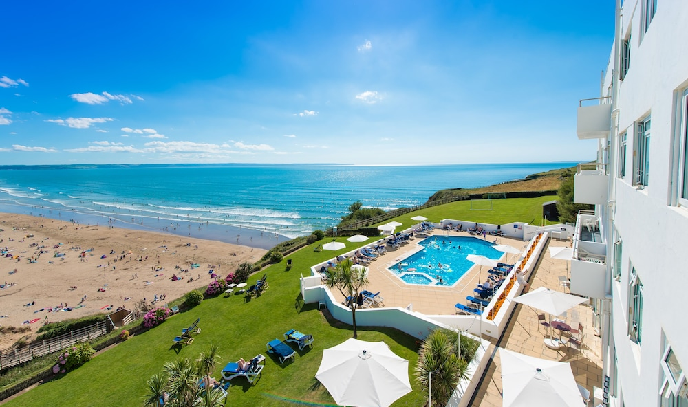

Society of Devon Intensive Therapists Annual Meeting
Thursday 6th – Friday 7th^{h} June 2024
Saunton Sands Hotel
Registration Form

Name:
Job title:
Hospital:
Email address:
Telephone number:
Special dietary requirements:

Please Indicate Choices: |  |  | Before 1st May | After 1st May
Full meeting including  accommodation (8th June), Reception drinks, Society Dinner & live entertainment | Consultant |  | £365 | £395
 | Medical Trainee/ACCP |  | £290 | £310
 | Nurse or AHP |  | £250 | £270
£20pp discount for sharing a room Name of person sharing with:
Guest or Partner (not attending meeting) Society Dinner 8th June & bed and breakfast |  |  | £170 | £170
Day Delegate – 6th June | Doctor |  | £100 | £100
 | Nurse or AHP |  | £80 | £80
 | +Dinner |  | £45 | £45
Day Delegate – 7th June | Doctor |  | £100 | £100
 | Nurse or AHP |  | £80 | £80
Total Payable

Rooms are limited, confirmation of booking will only be made on receipt of payment

BACS Transfer to “Society of Devon Intensive Therapists” Acc no 50542946 S/C 20-68-10

YOU MUST EMAIL A COPY OF THE BACS RECEIPT WITH THIS COMPLETED FORM WITH YOUR NAME AS THE REFERENCE OR WE CANNOT TRACE THE MONEY & CANNOT CONFIRM YOUR PLACE!

Please send the BACS receipt and completed form to: tracey.palmer2@nhs.net

